

APRIL 2026 END OF MONTH FINANCIAL REPORTS

Page 2 – EOM Sustaining Membership and Revenue Charts and Graphs

Page 4 – EOM Financial Summary Reports

Page 6 – Statement of Activities – Actual to Budget

Page 9 – Statement of Financial Position Curr v. Prior Month Comparison

Page 11 – Statement of Cash Flows

Page 12 – Related Party Transactions

Page 12 – Chair’s Discretionary Disbursements

End of Month Reports – Charts

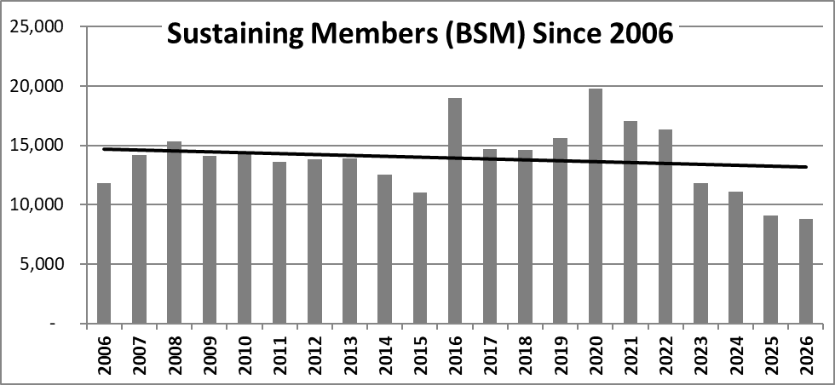

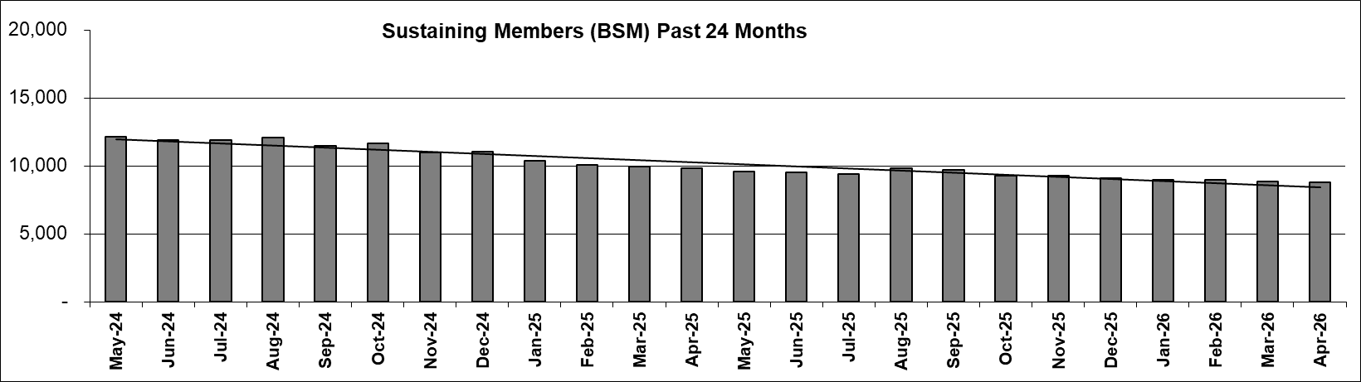

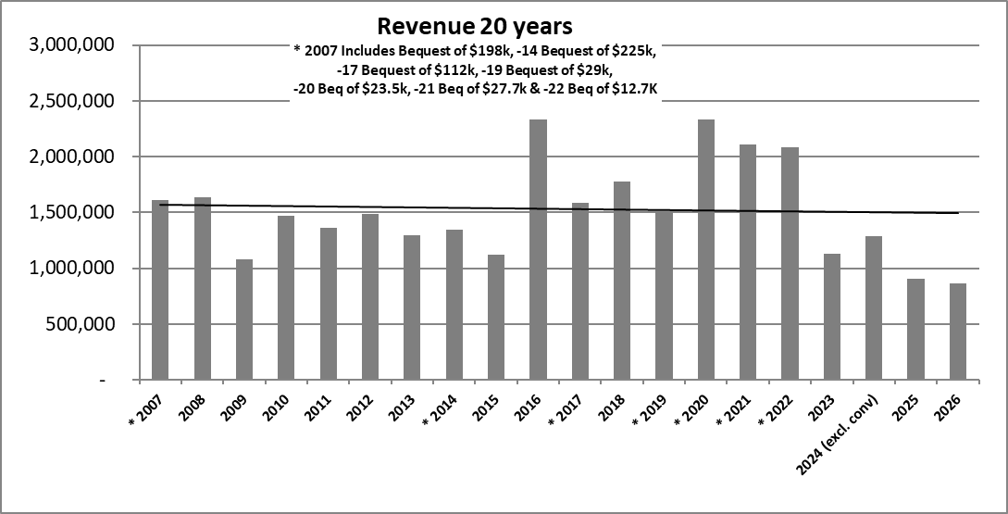

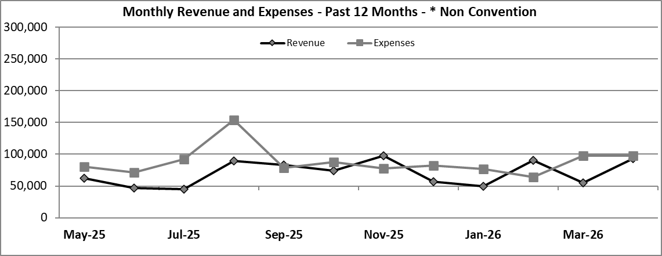
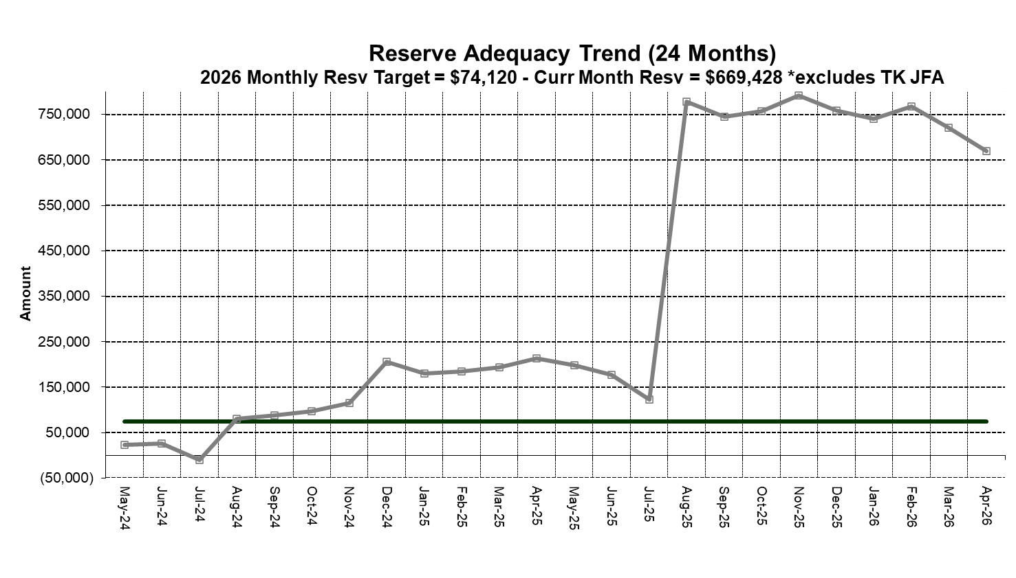

End of Month Reports – Financial Summary

